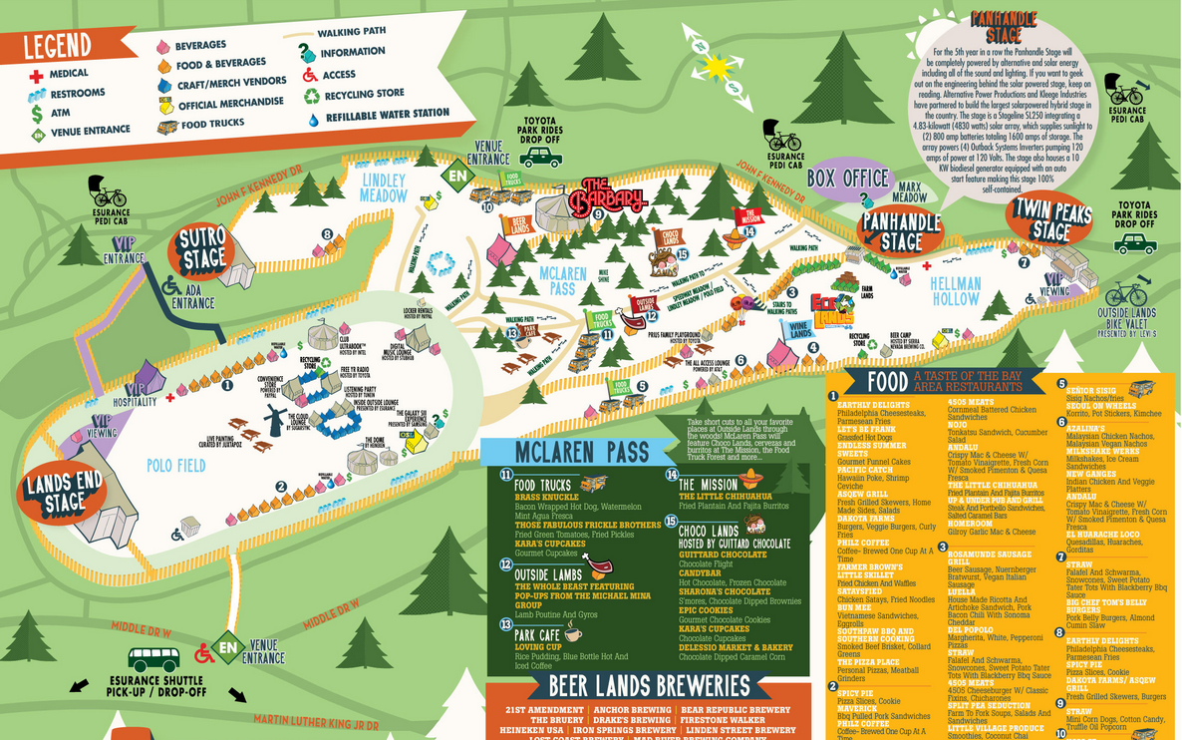
Jen 415-205-1362 - managing
Loyds:
Violet 415-515-7978
Sarah 323-717-1133
Serina 908-303-8220 or 510-735-5749
Brian 510-213-2403
Zoi - 510-835-1744 (landline)
Gadje:
Greg - 510-301-0906
Mike - 774-279-6416
Noah - 646-281-5833
Jeff - 415-335-8674
Paul M - 510-325-9574
Ofir - 818-915-8125
Morgan - 415-756-2281
Paul B - 415-867-8916
Andrew - 508-294-2256
Peter Bonos - 707-477-4582
Will Magid - 650-279-8166
Danny Cao - 415 425 4982

Meet at 1pm at Simple Pleasures Café 3434 Balboa Street to pick up tamper resistant wristbands good for all three days. If you are not performing all three days, wear your wristband loose so it may be removed without breaking the tamper seal! We need to use it for the performers on the following day. Return the wristband to Jen or Violet at the conclusion of our 2nd set of the day. If you are running late text Violet and Jen with your name, role and estimated arrival time.
We enter at the VIP entrance around 36th and Fulton. Note that bike valet is by the East entrance. Bags will be searched by security: glass & liquids not allowed.
We’ll meet inside the event at the VIP hospitality tent at 1:45 PM.
At 2:10 we head to Stub Hub tent in Polo field, to be ready to play there at 2:40. The festival organizers will give us a quick rundown then lead us on our parade.

If we are not on time our call times for the next days are going to be padded and we'll have to stand around for an hours before we play.

The schedule will be different each day, check your email each day before leaving the house. Tentatively:
Saturday call time 1 PM and done playing by 4 PM
Sunday call time is NOON and done playing by 6pm

We have no backstage. There will probably be a small container to store instruments in between sets. There is nowhere to store valuables while we are performing. Try to coordinate with those that have parking passes so you can put valuables in their car.
Your wristband gets you into the VIP areas where there's an open bar and a couch to sit on.

