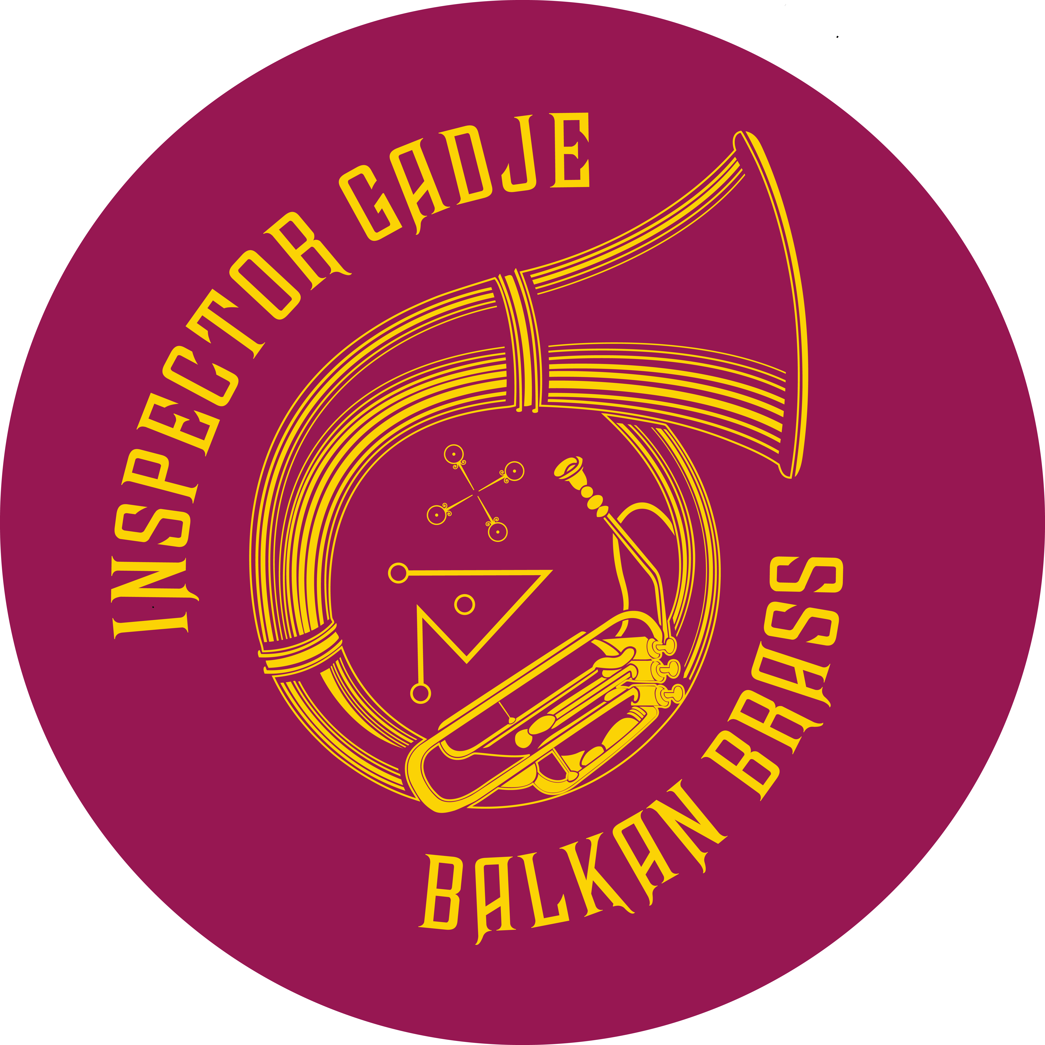

Inspector Gadje brings a big sound to the beautiful brass band music of the Balkans – inciting joy and dancing from the first downbeat. The name is a wink to the 1980’s cartoon show “Inspector Gadget,” and to the band's “gadje” (non-Romani) identity and their efforts to breaking “Gypsy” stereotypes.

2nd Sasa (Paul Marini)
Oliverov
K.O. Cocek (Kocani Orkestar)
Kashalbashki (Martin Lubenov Orkestra)

History
Original inspiration for the group came from many years of collaboration between the Brass Liberation Orchestra (BLO), a progressive social activist street band, and the Voice of Roma, a non-profit organization that supports Romani community and cultural causes world-wide. In 2009, after years of working together, Voice of Roma secured grant funding from the Haas Foundation to teach traditional Romani music to the BLO through an intensive six months of study with master Bulgarian-Romani musician Rumen “Sali” Shopov and local Balkan musician, Peter Jaques. Members of the BLO recruited additional musicians to join them in continued study and performance of Balkan music through Inspector Gadje.

Members

Noah Levitt - Trumpet
Danny Cao - Trumpet
Morgan Nilsen- Clarinet
Paul Bertin - Alto Sax
Mike Perlmutter - Alto Sax
Ofir Uziel - Accordion
Paul Marini - Baritone Horn
Jeff Giaquinto - Baritone Horn
Greg Stevens - Baritone Horn
Andrew Cohen - Helicon
Sean Tergis - Percussion
Marco Coppola - Percussion

www.Inspectorgadje.com

